10845948

YAA DUFIE QUANSAH

AHA DATABASE

**REPORT ON THE ANALYSIS OF HOSPITALS IN THE UNITED STATES OF AMERICA.**

This is a well-structured report on the Big Data Case named the AHA database which contains observations for twelve variables on over 2000 U.S. hospitals. This report contains descriptive statistics about the hospitals and has useful information that can assist business decision makers to understand these hospitals and make more thoughtful information-based decisions. The variables used include State, Region, Control, Service, Number of Beds, Number of Admissions, Census, Outpatient Visits, Number of Births, Total Expense, Payroll Expense, and Personnel. The variables are defined as follows;

1 = New England: Connecticut, Maine, Massachusetts, New Hampshire, Rhode Island, Vermont

2 = Mid Atlantic: New Jersey, New York, Pennsylvania

3 = East North Central: Illinois, Indiana, Michigan, Ohio, Wisconsin

4 = West North Central: Iowa, Kansas, Minnesota, Missouri, Nebraska, North Dakota, South Dakota

5 = South Atlantic: Delaware, Florida, Georgia, Maryland, North Carolina, South Carolina, Virginia, District of Columbia, West Virginia

6 = East South Central: Alabama, Kentucky, Mississippi, Tennessee  
7 = West South Central: Arkansas, Louisiana, Oklahoma, Texas  
8 = Mountain: Arizona, Colorado, Idaho, Montana, Nevada, New Mexico, Utah, Wyoming 9 = Pacific: Alaska, California, Hawaii, Oregon, Washington

Control is a type of ownership. There are 6 categories of control included in the database and they are;

1 = government nonfederal  
2 = government federal  
3 = osteopathic

4 = nongovernment nonprofit

5 = investor-owned for-profit

6 = other nonprofit

Service is the type of hospital. The 15 types of hospitals used in this database are:

1 = general medical and surgical  
2 = rehabilitation  
3 = orthopedic

4 = children’s  
5 = hospital unit of an institution (prison, college, etc.)

6 = surgical  
7 = psychiatric  
8 = alcoholism and chemical dependency  
9 = intellectual disabilities

10 = long-term acute care  
11 = heart  
12 = cancer  
13 = women’s obstetrics & gynocology

14 = other specialty

15 = chronic disease

The database also contains a sub database that is the Small Hospital database, for hospitals with 40 beds or fewer, using the same variables.

Charts and graphs made from the database are as follows;

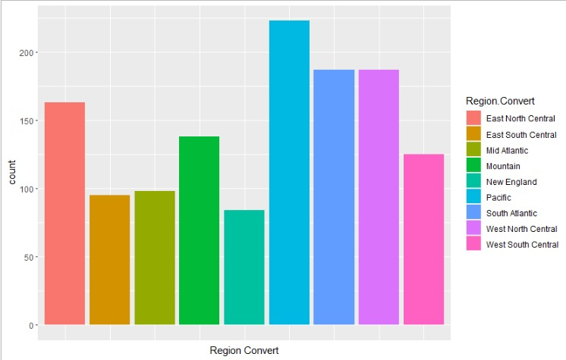

This bar chart is a display of the number of hospitals in each region. The Pacific region has the highest number of hospitals and New England has the least number of hospitals. The Pacific region comprises of Alaska, California, Hawaii, Oregon, and Washington. And the New England region consists of Connecticut, Maine, Massachusetts, New Hampshire, Rhode Island and Vermont. There are 26 small hospitals in the Pacific region and 13 small hospitals in that of New England.

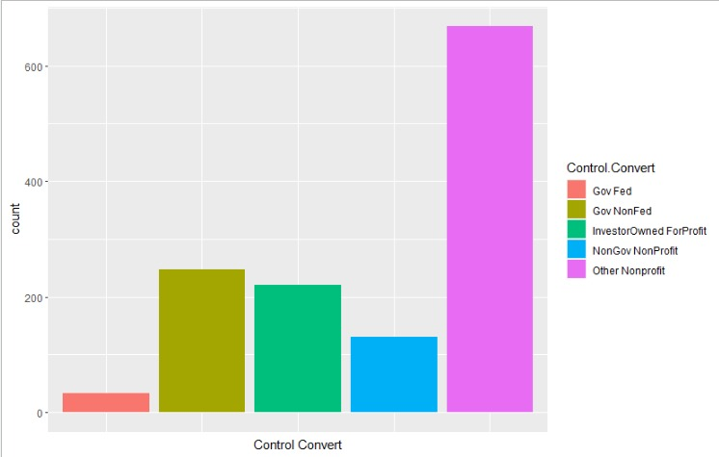

The bar chart above displays the number of hospitals owned by Government nonfederal, Government federal, Investor-Owned For-profit, nonGovernment nonprofit and other nonprofit. From this chart, it is shown clearly that the nonprofit organizations own the most hospitals whilst the Government Federal own the least.

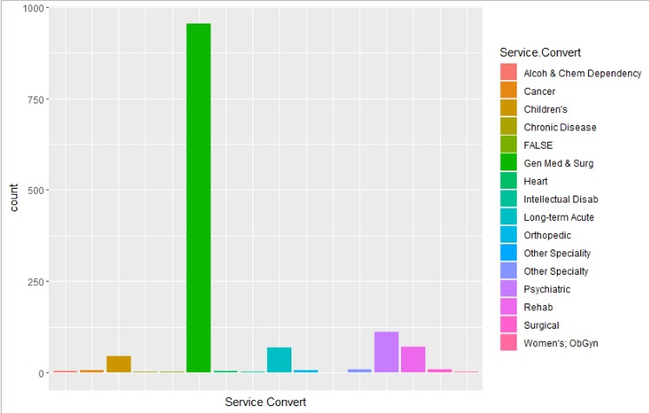

This bar chart above displays the Service Convert against the number of people who visit the hospitals rendering those services. The bar shows the hospitals with the most number of patient visits and least visits. The general medical and surgical hospital is visited the most for medical and surgical checks. And the Women’s Obstetrics & Gynocology, intellectual disabilities, chronic disease, other speciality hospitals are the least visited for issues regarding the services rendered in each of the hospitals.

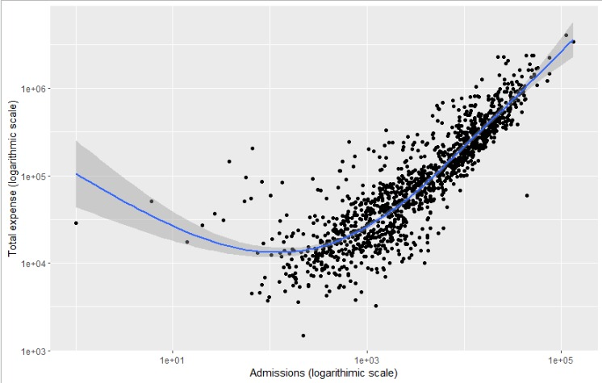

This is a scatter plot to establish the relationship between the total expense and number of admissions in the hospitals. From the plot, there is a positive correlation between the total expense and number of admissions. And so, as the admission increases the expenditure of the hospitals increase.

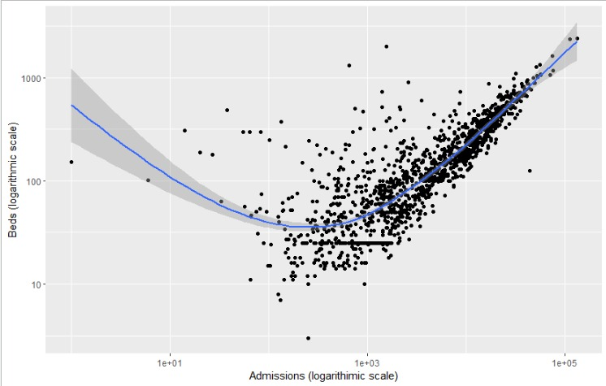

This was my last plot made from the database. This plot was to check if there is any relationship between the number of beds and the admissions. And it is quite evident the relationship between the two is positive. Also, it can be seen that hospitals that have higher number of beds have high admissions.

**CONCLUSION**

From the analysis, more hospitals rendering general medical and surgical services should be built across the country. Hospitals with smaller number of bed must construct more beds in order to have more admissions. And, the Government Federal should build more hospitals in the country.